Multiple Choice:

1. HTML is also known as Hyper___________ Markup Language
2. Transfer
3. Text
4. Transcript
5. Test

Answer: B

1. HTML is the most basic building block of the Web. It defines the meaning and ____________ of web content.
2. Design
3. Functionality
4. Behavior
5. Structure

Answer: D

1. An HTML element is set off from other text in a document by ___________.
2. Tags
3. Brackets
4. Case sensitive words
5. Images

Answer: A

1. WHATWG is an organization that maintains and develops ____________.
2. Systems
3. Websites
4. HTML
5. Documents

Answer: C

1. ____________ Headers applies to both requests and responses but with no relation to the data eventually transmitted in the body. _________ Headers Contains information about the resource to be fetched.
2. Request, General
3. Response, Information
4. General, Request
5. Data, Information

Answer: C

Abbreviation:

1. XHTML ***EXTENSIBLE HYPERTEXT MARKUP LANGUAGE***
2. DTD ***Document Type Definition***
3. WHATWG ***Web Hypertext Application Technology Working Group***
4. HTML ***HyperText Markup Language***
5. XML ***Extensible Markup Language***

Matching Type:

**2**

**1**

Choices:

1. Content
2. Title
3. Opening Tag
4. Open Post Tag
5. Paragraph
6. HTML
7. Closing Tag
8. Close Post Tag
9. Print Tag
10. Element

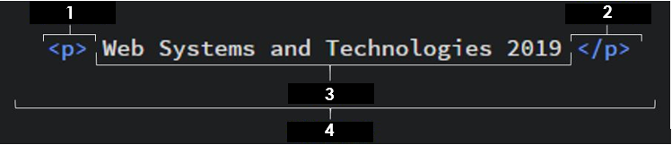

1. Choose from the choices given
2. Choose from the choices given
3. Choose from the choices given
4. Choose from the choices given

Identify what is being asked, choose from the given choices above:

1. What does <p> mean?
2. This consists of the name of the element, wrapped in opening and closing angle brackets.
3. This is the content of the element, in most cases it is just a text.
4. This states where the element begins or starts to take effect.
5. This states where the element ends, failing to add this is one of the standard beginner errors and can lead to strange results.
6. This comprises the whole figure above.

Answers:

1. C
2. G
3. A
4. J
5. E
6. C
7. A
8. C
9. G
10. J

From the given figure below, identify which part is being described.

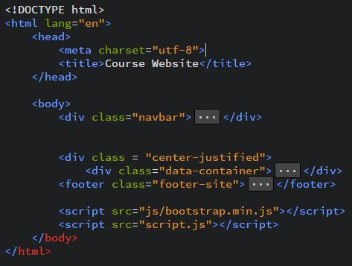

1. It is used to describe the page when you bookmark/favorite it.
2. This element wraps all the content on the entire page and is sometimes known as the root element.
3. This element sets the character set your document should use which includes most characters from the vast majority of written languages.
4. This sets the title of your page, which is the title that appears in the browser tab the page is loaded in.
5. This was meant to act as links to a set of rules that the HTML page had to follow to be considered good HTML, which could mean automatic error checking and other useful things.
6. This element acts as a container for all the stuff you want to include on the HTML page that isn't the content you are showing to your page's viewers.
7. This contains all the content that you want to show to web users when they visit your page, whether that's text, images, videos, games, playable audio tracks or whatever else
8. This includes things like keywords and a page description that you want to appear in search results, CSS to style our content, character set declarations and more.
9. Essentially, it can now handle any textual content you might put on it. There is no reason not to set this and it can help avoid some problems later on.
10. This is needed to make sure your document behaves correctly.

Answers:

1. **<title></title>**
2. **<html></html>**
3. **<meta charset="utf-8">**
4. **<title></title>**
5. **<!DOCTYPE html>**
6. **<head></head>**
7. **<body></body>**
8. **<head></head>**
9. **<meta charset="utf-8">**
10. **<!DOCTYPE html>**